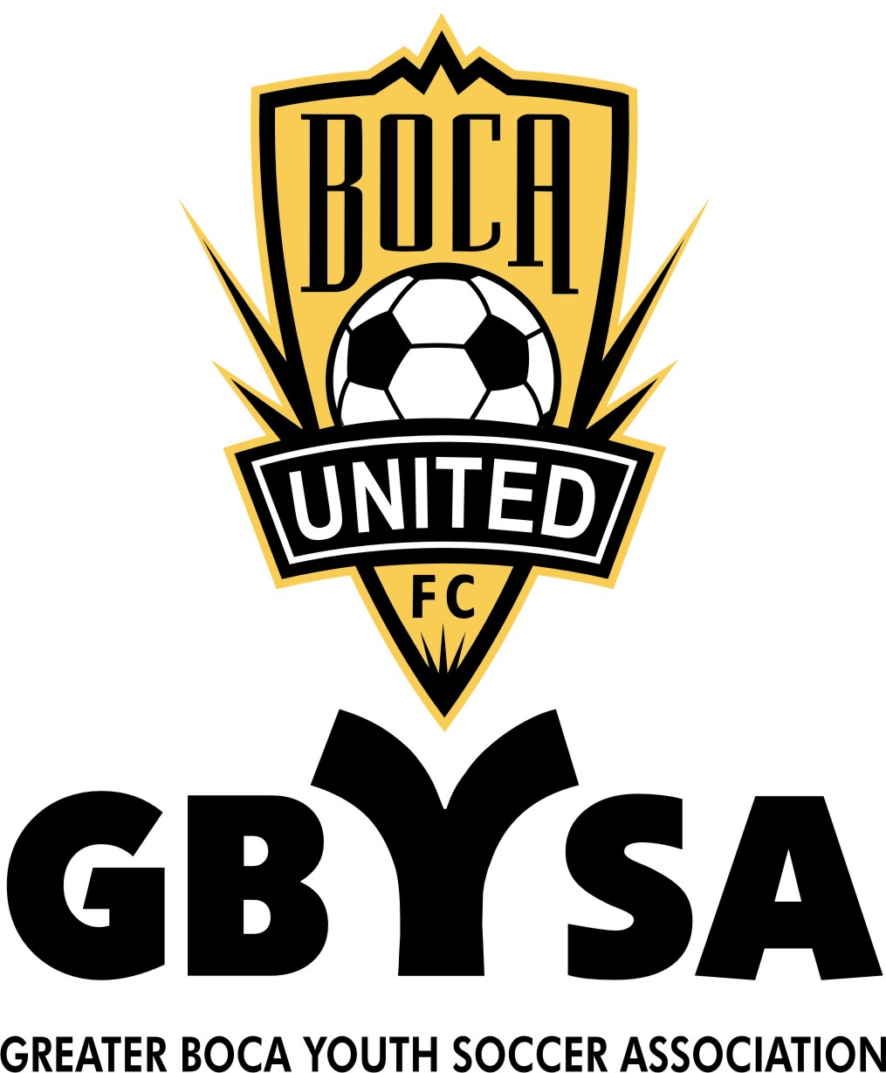

Dear Sponsor:
Greater Boca Youth Soccer Association Inc. (GBYSA) is a not-for-profit organization which oversees a full range of youth soccer programs in West Boca. GBYSA is administered entirely by volunteers; none of the officers are compensated for their time. Each year, GBYSA looks to community leaders like you to help ensure the success of our programs by sponsoring one or more teams and/or our organization in general. A basic, tax-deductible sponsorship fee of $15,000.00 includes the following:
You’re Logo on Front of One Recreational Teams Jersey in every age group.
You’re Logo on one Sleeve of all Kindergarten & all other Recreational Teams Jersey
Your Logo on Back of all ATP Age Groups Practice Jersey’s and
Choice of Front or Back of 2 ATP Age Groups Game Day Jersey
and a Patch on Sleeve of all other ATP Jersey’s
Have “your” Logo on our web-site, with a link to your site Listed in our directory

Club or team photograph “Thank You” Plaque
Acknowledgement in the year-end “Thank You” ad to run in the local newspaper
Our cooperation in distributing your flyers, coupons or other information
about your business to our players and their families.
An invitation to the awards ceremony at the end of the season.

GBYSA/Boca United FC offers a wide range of additional sponsorship opportunities, sponsor acknowledgements depending on contribution level. For details, please visit the GBYSA Web site www.gbysa.org or contact the Director of Sponsorship at gbysa_funding@gbysa.org.
If you would like to be a GBYSA sponsor, please complete the information below and mail this form, along with your logo/artwork and a check in the amount of $15,000.00, payable to GBYSA, to GBYSA Sponsor, PO Box 880544 Boca Raton, FL 33488-0544.

Sponsor Name:
Contact Person at Business:
Team Preference (by age, player or coach):
Name of Team (if other than business name):
Address:
Telephone:( ) - E-mail:
Team Age U- Boys Girl
Remarks:
ARTWORK MUST BE SUBMITTED NO LATER THAN July 10th.
ALL LOGOS WILL BE 1 COLOR (BLACK OR WHITE)
Visit our Web site www.gbysa.org
Greater Boca Youth Soccer Association is a registered 501c3 non-profit organization. All donations are tax-deductible to the extent allowed by law. A copy of the official registration and financial information may be obtained from the Division of Consumer Services by calling toll-free (800-435-7352) within the state. Registration does not imply endorsement, approval, or recommendation by the state.

